# Naming Convention class

At the beginning of our work, we decided that we are going to need some kind of a naming convention interface that would be implemented by most of the classes in the project to prevent bugs, caused by spelling mistakes. Upon further consideration, however, we discovered that this interface was mostly going to be used in the top layer of our program to coordinate the interaction between the Servlet and the .jsp files, and that was a problem, because .jsp files cannot implement interfaces. They can, however, use the import statement to import classes. That is why we agreed that instead of an interface, we should use a plain old class for this purpose. A class, which serves as something like a pseudointerface. The only reason it remains placed in the ***layer2.domain.interfaces*** package, instead of being moved to the first layer is because, as I previously mentioned, it is heavily referenced in the majority of the .jsp files, and even if we use NetBeans’ refactor move option, we would still have to change all of the import statements in the .jsps by hand, and that is something that we cannot afford to do, due to time constraints.

# Log-In and Security

Since we were going to have at least two different types of users, using the product, and since developing a log-in system that actually checks for someone's username and password seemed like a rather lengthy process, we decided that, at least until we're done with the more important user stories first, we would need some kind of a dummy log-in system that would easily allow us to log-in and test the system.

The idea I came up with is the following: In order for us to log-in as an admin (dell user), we would have to type "admin" in the email field *[*Note: At this point, we were still using emails for logging-in, which we later replaced with a username]* and just some random characters in the password field. And in order for us to log-in as a partner of dell, we would just type random characters in both input fields and get in.

It works the following way. First, we manually populated the database with one tuple of each of the two different types of users we would have, via INSERT INTO queries. Then, we wrote the code, so that once the log-in button on the index page is pressed, the Servlet would only check for the email parameter. If it was “admin”, it would start the chain calling of the dummy ***getAdmin()*** methods which went through the Controller class all the way down to the dataSource layer. And if the email parameter was not “admin”, it would call the dummy ***getReseller()*** methods. Once in the dataSource layer (the DBFacade, to be more precise), the correct userID’s were hard-coded and passed as arguments for the mappers to use and retrieve the needed user.

*Note: At this time, we were still using the “reseller” terminology for dell’s partners, which was later dropped.

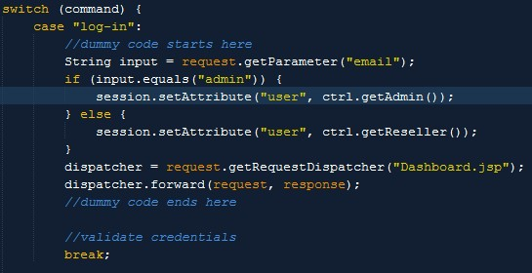

*Dummy Log-In [Note: At the time this screenshot was taken, we were still using the email for logging-in]*

One week before the project deadline, however, we determined that it was time to handle logging-in the proper way, so we dropped this dummy implementation. Now when a user tries to log-in, the following takes place:

1. The program checks if a user with the entered username exists in the database.
2. If so, it checks if the entered password corresponds to the one stored for this user.
3. Then, if all went well, the log-in has been successful.

We are aware of the fact that this is in no way a secure log-in as we are breaking the first rule of password storing, which is never to store non-hashed values of passwords anywhere and that’s exactly what we’re doing (by storing them in the database). However, time constraints were once more the thing that made us decide not to implement a hashing algorithm for the passwords.

Nevertheless, one of the things we did concerning security was to split the user information into two different tables – one that stores the general information for the user and one that stores his log-in credentials and more sensitive information (e.g. email), called respectively UserInfo and UserAuthentication. That way, when we create an object of the type UserInfo and we use it throughout the program, we don’t carry around all the sensitive information with us.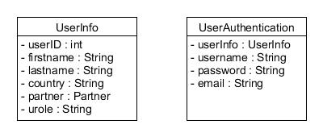

# Servlet

Since our application was not going to be too big, we decided to have one servlet that handles all requests. In this manner, we would have a centralized code-flow, while still keeping the code in the servlet manageable.

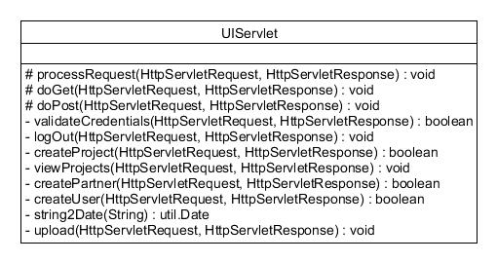

For the implementation, we relied on the examples, given to us before the project start. The first thing we do whenever a request is sent to the servlet and into the ***processRequest()*** method is to attempt to retrieve the Controller object from the session. If no such object exists, we create one and set it as an attribute of the session, so we can access it later as long as the same user is still logged-in. Later, we realized that we don’t need to do that because we don’t actually store any user-related information in the Controller, so we could just make a new one every time the ***processRequest()*** is called, but by the time we had this realization, we had already finished coding.

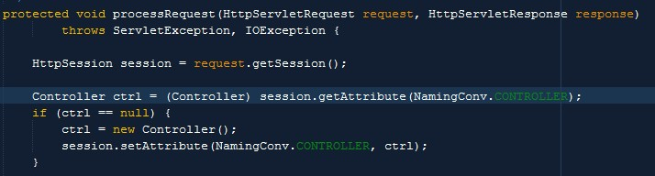

The next thing that happens is we try to retrieve the command attribute from the request object. If it’s not there, then we take it from the session, because we’ve constructed the .jsp pages in such a way that whenever a call to the Servlet is made, there is always a command attribute either in the request, or in the session.

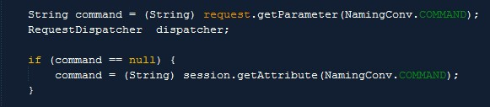

After that, we have two big nested switch-cases. Our logic here is the following. If the user has pressed one of the sidebar menu buttons, then all the application would have to do is reload the main area of the dashboard with a new page. Hence, in this case we set the command to be “reloadMain” and we also add another attribute to the request, called “mainArea”, which holds information on which .jsp should be shown in the main area. Anything else the user wants to do is a different command and is handled by corresponding methods.

# Design class diagram

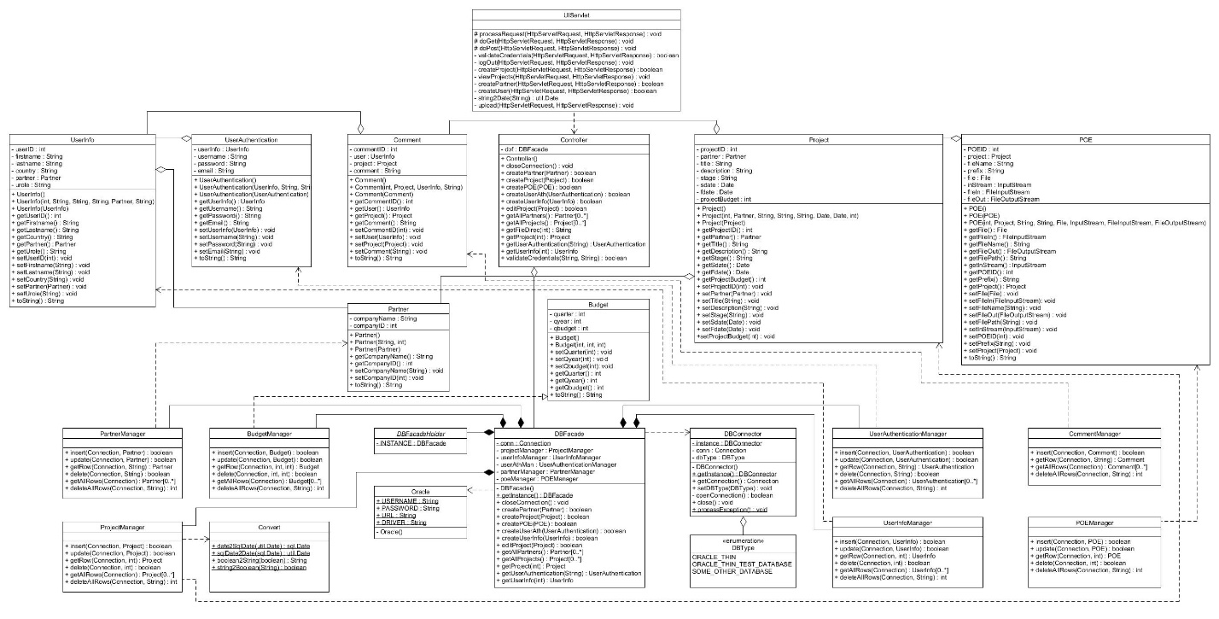

*[*Note: Check .jpg file for a zoomable version of this diagram]*

The diagram is designed in such a way that it also reflects the layer structure of our program.

The only class that isn’t included in this diagram is the NamingConv class, because it has no methods of its own and stores a huge number of static Strings.

# Sequence diagram

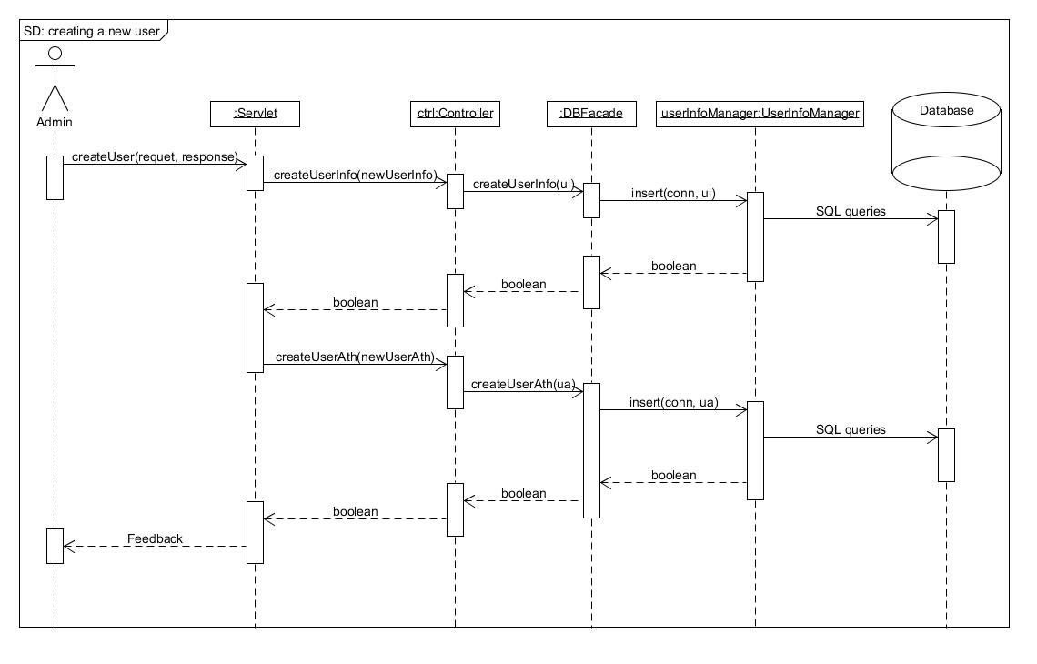

For the sequence diagram, we decided to depict the process of adding a new user to the database.

When the admin user (dell person) fills out the form for creating a new user and clicks “Add user”, the request is sent to the Servlet where the ***createUser()*** is called. There the newly-created UserInfo and UserAuthentication objects are exrtacted from the session. Afterwards, it the UserInfo is put in the database and a Boolean value is returned all the way back to the Servlet to convey if the insertion went well. During the insertion, the UserInfo object gets a valid UserID from the UserInfoSequencer. Afterwards, back in the Servlet the UserInfo object (now containing a proper UserID) is assigned to the UserAuthentication object, followed by its insertion in the database. The user is then given feedback if it all went well or not.

# Database schema

Budget (quarter, qyear, qbudget)

Partner (companyName, companyID)

UserInfo (userID, firstName, lastName, country, **compayName**, urole)

UserAuthentication (username, password, email, **userID**)

Project (projectID, **companyName**, title, description, stage, sdate, fdate, projectBudget)

POE (POEID, **projectID**, prefix, filename, fileBin)

Comments (commentID, **projectID**, **userID**, comments)

The schema we ended up with is much different from the one we had in the beginning. We had to change it many times throughout the development and this slowed us down a lot with the coding process, because every time we changed something in the tables, it reflected in the code, so we would have to make changes to it as well.

We are aware of the fact that the schema we have now is in no way perfect. One of its major flaws is the Partner table. Instead of using a sequencer to auto-generate unique values for the companyID attribute, which we could then use as a primary key, we have, for some reason, chosen to use the companyName as a primary key, rendering the companyID useless.

I suppose this mistake was made out of frustration, because it happened when the team was in a little bit of a crisis. Furthermore, it wasn’t noticed until after the code had been adapted to this schema and we just couldn’t afford to waste one more second on changing existing code to fit new table changes. That is why, we just kept it this way.

# Preserving the database relations into the program

One of the first problems we faced was the fact that if we were to create the domain classes in such a manner that they strictly followed the database table layout and the types of data stored in them, then we would lose the relations between the different tables. For example, if we were to make the UserAuthentication class store the userID as an integer (the way it’s stored in the database), then we would have no way of knowing which UserInfo object this userID is pointing to.

That is why; we decided that if a given attribute is a foreign key in a table, then that attribute should be of the type, which it is referencing. To clarify, in the above example, the userID in the UserAuthentication class wouldn’t be of type integer. It would be of type UserInfo. That way, we get to keep the relations between the different tables into the world of Java objects.